ESCUELA DE COMERCIO N°1 “PROF. JOSÉ A. CASAS”
NAME:__________________________________________
CLASS: __________________

Activity 10
DAILY ACTIVITIES

- Look at the following chart. This chart is about the rules for the 3rd person singular verbs in the Simple Present.
Mira el siguiente cuadro. Este cuadro trata sobre las reglas para formar la 3ra persona de los verbos en el presente simple. Recuerda que con las otras personas I, You, We, They , el verbo no se modifica. El verbo se modifica con las siguientes personas: He, she, it

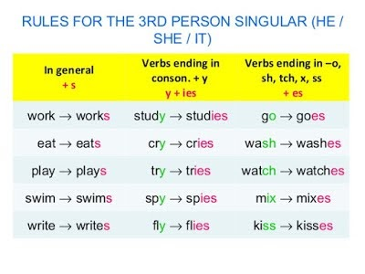

- Write the following verbs for the 3rd person singular
1. I join - he joins 2. I like - he ………… 3. I kiss- he …………….
4. I fly - he ……………. 5. I watch - he ………… 6. I enjoy - he …………….
7. I talk - he ……………. 8. I go - he ………… 9. I teach - he ……………
10. I buy - she …………… 11. I finish - she ……….. 12. I cry - she ……………

3. Use the verbs in brackets to complete the sentences, as in the example:
1. I ..live.. (live) in Edinburgh.
2. He ………. (do) his homework every evening.
3. She’s a teacher. She ……….. (work) at primary school.
4. “Are you a singer?” “No, I’m a pilot. I ………….. (fly) aeroplanes.
5. Joan …………. (wash) her hair every day.
6. The museum …………….. (close) at seven in the evening.
7. Daniel ……………. (brush) his teeth every morning.
8. She ……………... (study) Science at university.
9. Every Saturday, Paul …………… (wash) his car in the morning.
10. In the mornings, Betty …………… (take) her sister to school.
11. We ……… (go) to the swimming pool at the weekend.
12. John and Mary ………… (have) a cup of tea in the afternoon.

4. Complete Sara’s routine with the verb in brackets in the correct form in the Simple Present
Completa la rutina de Sara con el verbo entre paréntesis en la forma correcta en el Presente Simple

On weekdays, Sara___________(get ) up very early, she___________(have) a shower and ____________(put) on her school uniform. After breakfast she __________ (brush) her teeth. She______________(walk) to school because it__________(be) only ten minutes away. Her lessons_____________(start) at 8,30 and _____________(finish) at 4. She ___________(have) lunch at the school canteen. After school she ___________(go) home and __________(do) her homework. In the evening, she ___________(listen) to music. She__________(have) dinner with her parents at 9 pm. After dinner she _____________(watch) her favourite tv programme. She __________(go) to bed at 10 pm.

