ESCUELA DE COMERCIO N°1 “PROF. JOSÉ A. CASAS”
NAME:__________________________________________
CLASS: __________________

Activity 11

1- Look at the following chart. This chart is about the Negative Form in the simple
Present.
Mira el siguiente cuadro. Este cuadro trata sobre la Forma Negativa en el
presente simple.

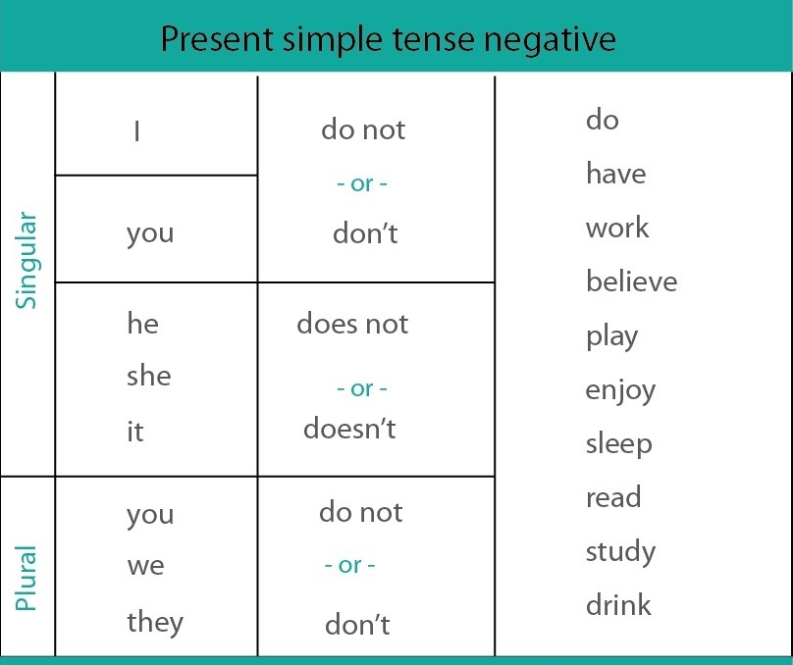

2- Make Negative sentences. Use don’t-doesn’t and the correct form of the verbs in brackets.
Escribe las oraciones en forma NEGATIVA. Usa DON’T o DOESN’T y la forma correcta del verbo entre paréntesis.

a- She __________________(eat) breakfast.
b-I _______________(have) a shower in the morning.
c-He________________(watch) tv in the evening.
d-They_______________(go) to bed early on Saturday night.
e-My sister_________________(have lunch) at home.
f-She_________________ (sing) nice songs.
g-My brothers_______________(get up) early.

3- Rewrite in the negative form . Escribe las siguientes oraciones en forma NEGATIVA

a- Irish people speak French.
______________________________________________
b-Water boils at zero degrees.
______________________________________________
c-Bart Simpson wears glasses.
______________________________________________
d-Vegetarian eat meat.
______________________________________________
e-Cristiano Ronaldo plays basketball.
______________________________________________
f-Lali Espósito sings in Japanese.
______________________________________________

4- Page 46 . Exercise 1. Une las frases a las imágenes correctas.
5. What do you do at home at weekends? Write sentences about you and your mother or father based on the activities in exercise 4 (page 46)
For example:
I don’t make my bed at weekends
My mom makes her bed at weekends

