ESCUELA DE COMERCIO N°1 “PROF. JOSÉ A. CASAS”
NAME:__________________________________________
CLASS: __________________

Activity 9
DAILY ACTIVITIES

- Click on the LINK and watch the video carefully and practise the vocabulary repeating all the phrases you can listen to and do the exercises.

https://youtu.be/zNDIhOXy3IU

- Look at the pictures and match
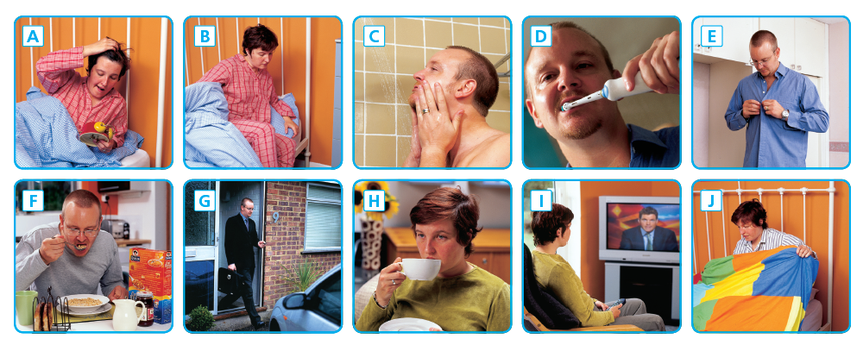

HAVE A SHOWER _____ HAVE BREAKFAST _____
GO TO SCHOOL _____ GET UP _____
WATCH TV _____ HAVE TEA/ COFFEE _____
GET DRESSED _____ GO TO BED _____
BRUSH MY TEETH _____ WAKE UP _____

- Page 44. Exercise 2: Read the dialogue and write the highlighted phrases under the correct pictures. Then listen to Pat and Emily and practise their conversation.
- Page 44. Exercise 3. Tick the things you do on Saturdays
- Page 44. Exercise 4. Write about your weekend

6.Vocabulary : Parts of the day
Match the phrases to the pictures
a- in the evening ____ c-in the morning ____
b-in the afternoon ____ d-at night ____

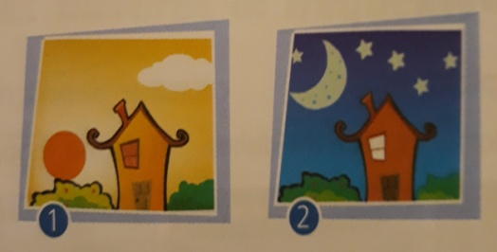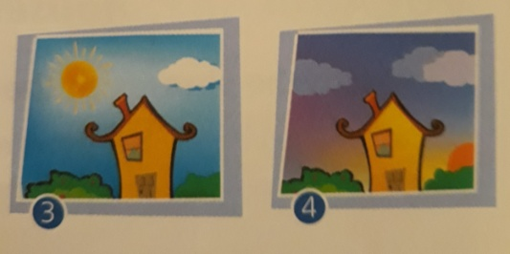

7-Write about your Saturdays

in the morning / afternoon / evening - at night

Example:
I get up at seven in the morning .
a- I watch tv _____________________________________
b-I do my homework _____________________________________
c-I have dinner _____________________________________

