ESCUELA DE COMERCIO N°1 “PROF. JOSÉ A. CASAS”
FULL NAME:__________________________________________
COURSE: 3ro Division: ___________

Activity 10

REVISION: COUNTABLE AND UNCOUNTABLE

ACTIVIDAD 1: Van a ingresar al siguiente link y van a resolver los ejercicios.

https://bit.ly/30naXlo

1. Write c for countable and u for uncountable
Escribe C para contables y U para incontables

2. Choose a, an, some or any
Elige a, a, an, some o any

3. Choose How much or How many
Elige How much o How many

Luego van a sacar captura de la pantalla y luego presionan DONE.
Luego que presionen DONE, sacan otra foto y envian adjuntados a su tp

Copiar en la carpeta desde aquí

Verb TO BE in the past

Iniciamos con un tema nuevo: el verbo to be en tiempo pasado. Hasta ahora solo habíamos usado el verbo to be en Presente: AM IS ARE cuyo significado podía ser SER, ESTAR, y TENER EDAD.
Ahora emplearemos WAS y WERE en tiempo pasado. Los significados de estos verbos sera los mismo que en presente, pero hay un cuarto significado: WAS BORN, WERE BORN, que significan NACER
Examples:

I was ten years old in 2010. Yo tenía diez años en el 2010.
I was at home at six. Yo estaba en casa a las 6.
I was a famous writer. Yo era un famoso escritor.
I was born in Jujuy. Yo nací en Jujuy.

ACTIVIDAD 2: Look at the chart and complete the text using WAS, WASN’T, WERE or WEREN’T
Name | Date of birth | Place of Birth | Occupation
Elvis Presley | 8th January | Mississippi, the USA | singer
Marilyn Monroe | 1st June, 1926 | California, the USA | actress
Pablo Picasso | 25th October, 1881 | Malaga, Spain | painter

- Elvis Presley _____________ born on 8th January. He _____________ born in California, the USA. He _____________born in Mississippi, the USA. He _____________ a famous singer known as the King of Rock and Roll.
- Marilyn Monroe _____________ a TV presenter. She _____________ an actress. She _____________ born in California, the USA. She _____________ born on 25th October, 1881. She _____________ born on 1st June, 1926.
- Pablo Picasso _____________ born on 25th October, 1881 in Malaga, Spain. He _____________ an astronaut. He _____________ a painter.

ACTIVITY 3: Copy the exercise in your folder and complete with WAS o WERE

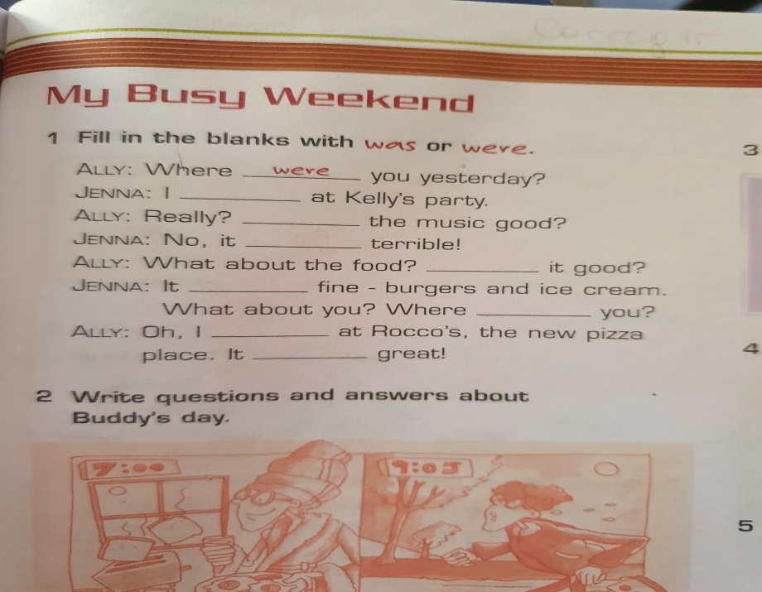

ACTIVITY 4: Answer these questions about yourself
- When were you born?
- Where were you born?
- When was your best friend born?

