ESCUELA DE COMERCIO N°1 “PROF. JOSÉ A. CASAS”
FULL NAME:__________________________________________
COURSE: 3ro Division: ___________

Activity 7

1-Read the following text carefully. Use the dictionary if necessary
Lee el siguiente texto cuidadosamente. Usa el diccionario si es necesario

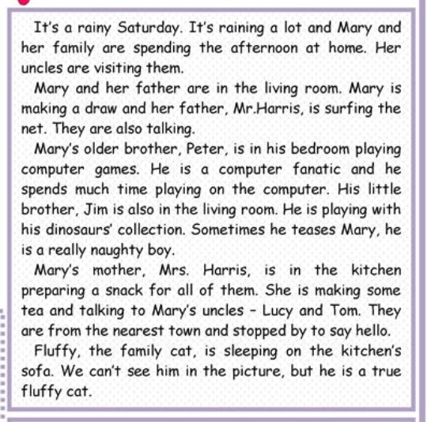

2-True or False ? Correct the false ones
Verdadero o Falso? Corrige las falsas

a-It is a rainy Sunday. T F
_____________ __________________________________________
b-Mary and he mother are in the living room. T F
_______________________________________________________
c-Mary´s father is making tea. T F
_______________________________________________________
d-Peter is reading a book. T F
_______________________________________________________
e-Fluffy is sleeping on the bed. T F
_______________________________________________________

3-Answer the questions about the text
Responde las preguntas sobre el texto
a-What day of the week is it?
__________________________________________________
b-Where is Mary?
__________________________________________________
c- Is she watching tv?
__________________________________________________
d-What is she doing?
__________________________________________________
e-Where is Jim?
__________________________________________________
f-What is he doing?
__________________________________________________

4. What are they doing? Use the following verbs: water / read / sleep /write
Que están haciendo? Usa los siguientes verbos: water / read / sleep /write

