ESPACIO CURRICULAR: LENGUA EXTRANJERA INGLES

CURSO: 4° DIVISIONES: 1°, 2°, 3°, 4°, 5°
ASIGNATURA: INGLES DOCENTE: - ANGELICA FLORES.
- NOEMI TOLABA.
- VICTOR JOSÉ ANTONIO CORONEL.
- EMANUEL YAMPE.
TEMA: THE COMPARATIVE DEGREE OF ADJECTIVES. (short and long adjectives)
TRABAJO PRACTICO N° 11

IRREGULAR ADJECTIVES

ADJECTIVES | COMPARATIVE FORM | SUPERLATIVE FORM
GOOD  (bueno) | BETTER (THAN)  …mejor que… | THE BEST  …el mejor…
BAD  (malo) | WORSE (THAN)  …peor que… | THE WORST  …el peor…
FAR  (lejos) | FARTHER (THAN)  …más lejos que…  FURTHER (THAN) | THE FARTHEST  …el más lejano…  THE FURTHEST
OLD  (viejo) | OLDER (THAN)  …más viejo que…  ELDER (THAN)- se usa con miembros de la familia exclusivamente. | THE OLDEST  …el más viejo…  THE ELDEST

- Complete the following sentences using the correct degree of the adjectives given in brackets.

- My brother's handwriting is (bad) mine.
- Health is wealth, (important)
- Blood is water, (thick)
- Everest is peak in the world, (high)
- This is play I have ever heard on the radio. (interesting)
- Susie is of all the four sisters, (beautiful)
- The planet Mars is from the earth than the satellite Moon, (far)
- The elephant is animal in the world, (large)
- An ocean is certainly a sea. (big)
- I am in cricket than in football, (interested)

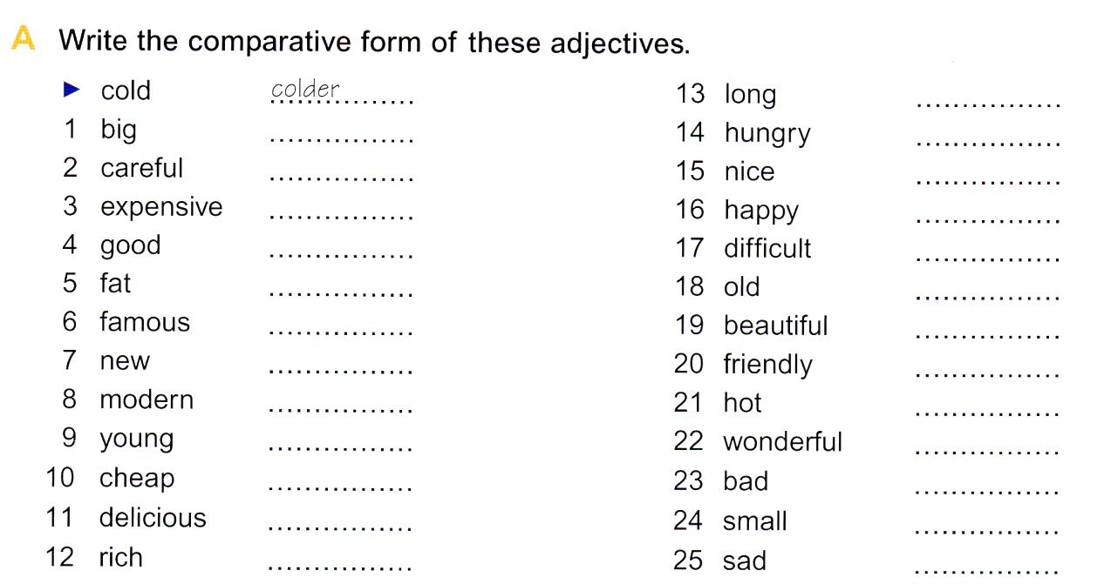

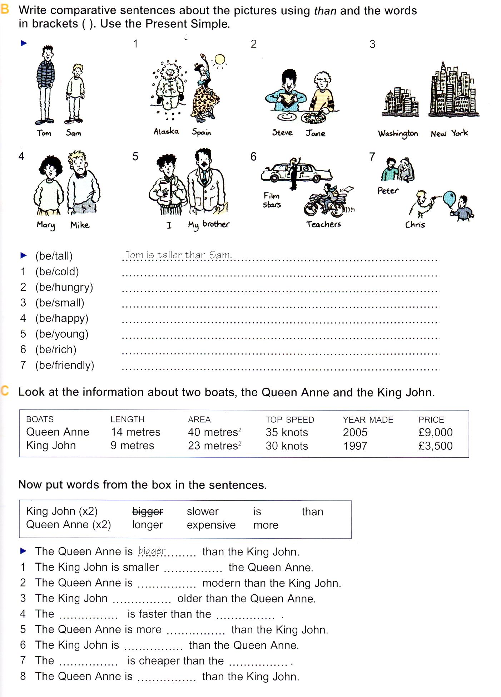

- coronelvictor@hotmail.com. Los alumnos de 4to 4ta y 4to 5ta pueden enviar sus trabajos a mi correo para ser corregidos y dar una devolución de los mismos.

- angie_delval@hotmail.com: Alumnos de 4° 2°

- noetolaba2077@gmail.com : Alumnos de 4° 3°.

- teacher_emmanuel@outlook.com : Alumnos de 4° 1°

