ESPACIO CURRICULAR: LENGUA EXTRANJERA INGLES
CURSO: 4° DIVISIONES: 1°, 2°, 3°, 4°, 5°
ASIGNATURA: INGLES DOCENTE: - ANGELICA FLORES
- NOEMI TOLABA
- VICTOR JOSÉ ANTONIO CORONEL
TEMA: THE PRESENT CONTINUOUS TENSE FOR FUTURE ARRANGEMENTS.
TRABAJO PRACTICO 8

- USE THESE WORDS TO WRITE SENTENCES. USE THE PRESENT CONTINUOUS.

- I – go to the theatre – tomorrow.
I AM GOING TO THE THEATRE TOMORROW.
- Tom – go to London – next Friday.
………………………………………………………………………………
- George – go to the dentist – on Friday
………………………………………………………………………………
- Elizabeth – not come – to the party this evening
………………………………………………………………………………
- What time – Anna – come for dinner tonight?
………………………………………………………………………………
- Bob – play football – tomorrow evening.
………………………………………………………………………………
- I – buy – some books – next Wednesday.
………………………………………………………………………………
- It – not go to rain – on Saturday.
………………………………………………………………………………
- Marcus – retire next month
………………………………………………………………………………
- The plane – arrive – at four o´clock
………………………………………………………………………………
- What – Jenny – do next Monday?
………………………………………………………………………………
- Where – you go?
………………………………………………………………………………

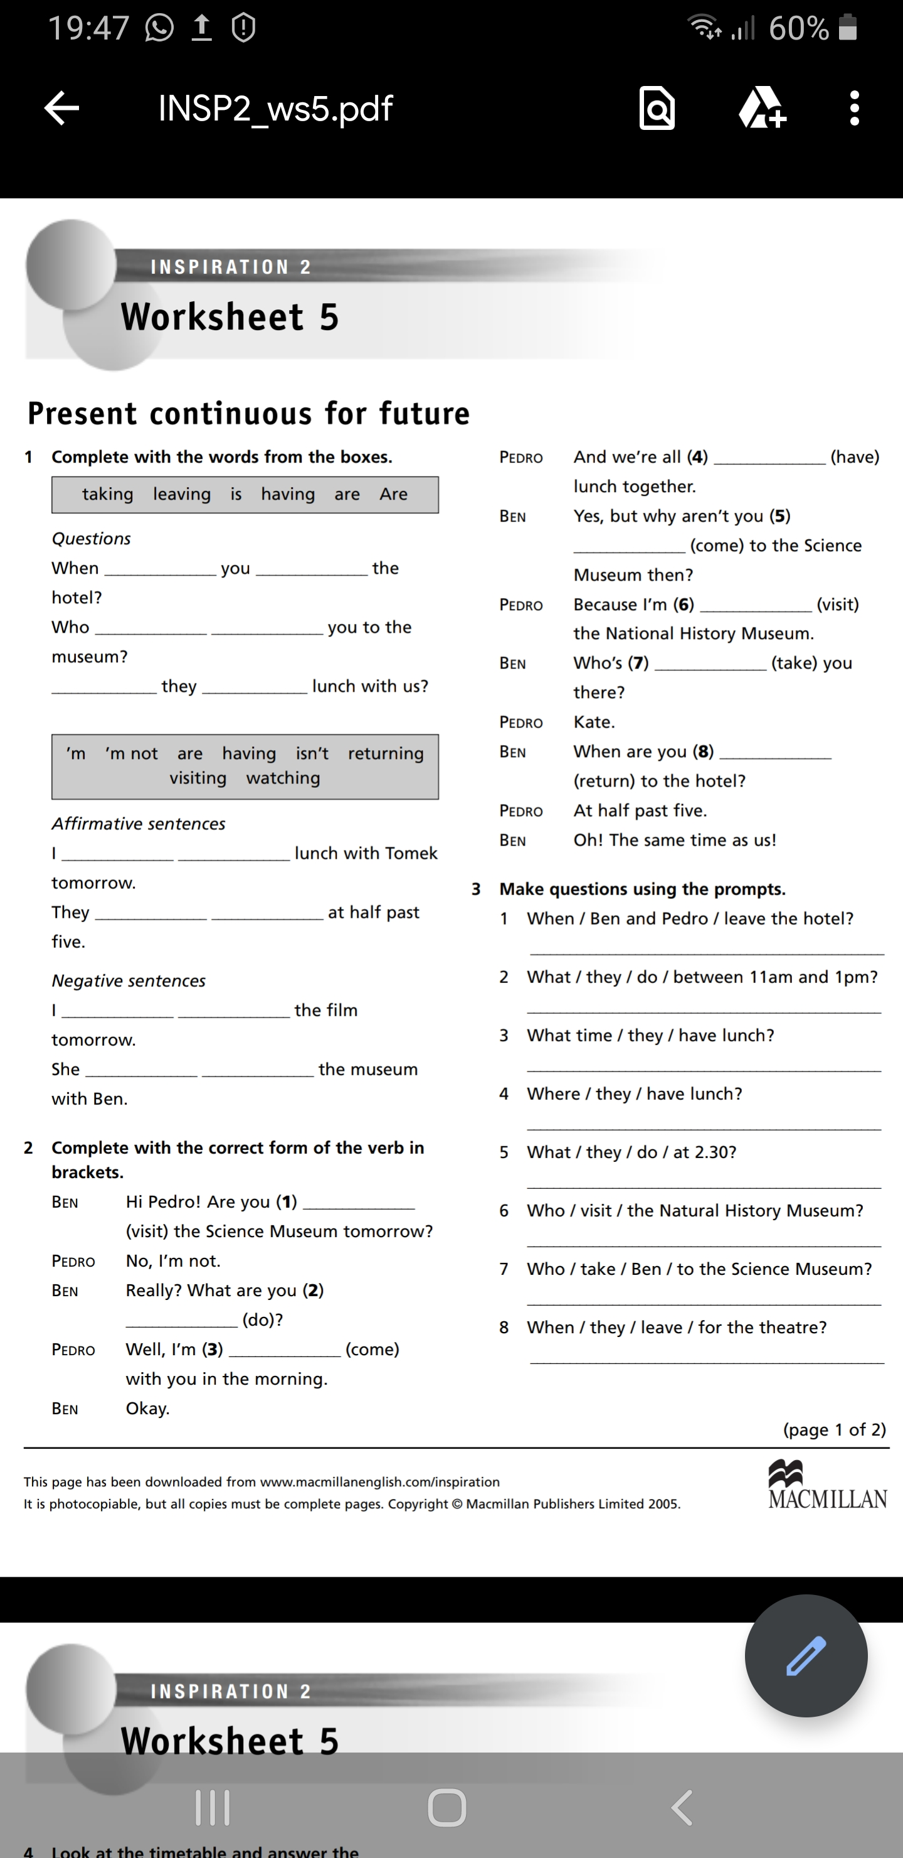
Mira este video en youtube que pueden aclarar más dudas de como uso el presente continuo con intención de futuro (planes):
https://www.youtube.com/watch?v=2ujS85Kc74s

- coronelvictor@hotmail.com. Los alumnos de 4to 4ta y 4to 5ta pueden enviar sus trabajos a mi correo para ser corregidos y dar una devolución de los mismos.

- angiedelval@hotmail.com: Alumnos de 4° 1° y 4° 2°

- noetolaba2077@gmail.com: Alumnos de 4° 3°.

