ESCUELA DE COMERCIO N°1- PROF. JOSÉ ANTONIO CASAS
TRABAJO PRACTICO N° 10
ESPACIO CURRICULAR: INGLÉS
TEMA: “PASADO SIMPLE VS. PASADO CONTINUO”
RESPONSABLES: LAURA ALANCAY, GABRIELA CHAVARRIA, JUAN JARAMILLO, ELIZABETH IBAÑEZ, ANDRÉS CORIMAYO
CURSO: 5°AÑO
Alumnos: enviar el trabajo para su corrección al correo de sus profesores:
-5to 5ta Prof. LAURA ALANCAY cecilialancay@gmail.com
-5to 3era Prof. GABRIELA CHAVARRIA gabj_ch@hotmail.com
-5to 1era Prof. JUAN JARAMILLO jack_jar007@hotmail.com
-5to 4ta Prof. ELIZABETH IBAÑEZ formulaely@gmail.com
-5to 2da Prof. ANDRÉS CORIMAYO corimayo.andres@gmail.com

NAME: …………………………………………………………………………………………

PAST SIMPLE vs PAST CONTINUOUS

GRAMMAR

Cuando usamos estos tiempos verbales juntos, la acción en PASADO SIMPLE interrumpe la acción en PASADO CONTINUO, mientras esta estaba en progreso

While I was studying, I suddenly felt asleep

Usamos PASADO SIMPLE y PASADO CONTINUO para mostrar que una acción es interrumpida por otra.
I broke my leg when I was skiing.
As I was going to work, I saw an old friend.
We were watching television when the power went off.

I started skiing
I broke my leg
(Past simple)
I WAS SKIING (Past continuous)

9 am 9,30 am 10am 10,30 am 11am

¿Puedes notar la diferencia entre en el significado de estas dos oraciones?

When the guests arrived, Jane was cooking dinner.
When the guests arrived, Jane cooked dinner.

En la primera oración, Jane comenzó a cocinar antes de que llegaran los invitados. Lo sabemos porque usa el PASADO CONTINUO.
Por otro lado, en la segunda oración, los invitados llegaron primero y luego, Jane comenzó a cocinar.

NOTA: Los conectores que se usan para relatar los hechos usando los dos tiempos verbales juntos son: WHEN, WHILE o AND

ACTIVITIES
- Look at the pictures. Putt he verbs in the correct form, PAST CONTINUOUS or PAST SIMPLE
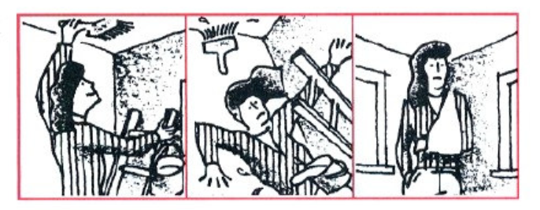

Lucy broke (break) her arm last week. It (happen) when she (paint) her room. She (fall) off the ladder.

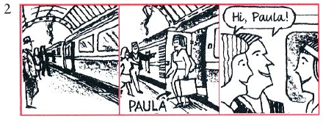
The train (arrive) at the station, and Paula (get) off. Two friends of hers, Jon and Rachel, (wait) to meet her
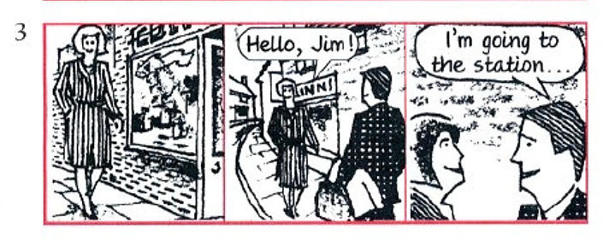
Yesterday Sue (walk) down the street when she (meet) James. He (go) to the station to catch a train, and he (carry) a bag. They (stop) to talk for a few minutes.
- Put the verb into the past continuous or simple past

- A: What were you doing (you/do) when the phone rang (ring) ?
B: I was watching (watch) television.
- A: I (lose) my key last night.
B: How (you/get) into your apartment?
A: I (climb) in through a window.
- A: What time (the package/ arrive) this morning?
B: It (come) while I (have) breakfast.
- A: (you/see) Jenny last night?
B: Yes, she (wear) a very nice jacket.
- A: How (he/break) the window?
B: We (play) football. He (kick) the ball and it (break) the window.

